Big Picture:
- Course focuses on physics of machines.
- Will explore fundamentals of torque production in machines.
- Will explore high performance torque and speed control of adjustable speed drives.

DC Machines

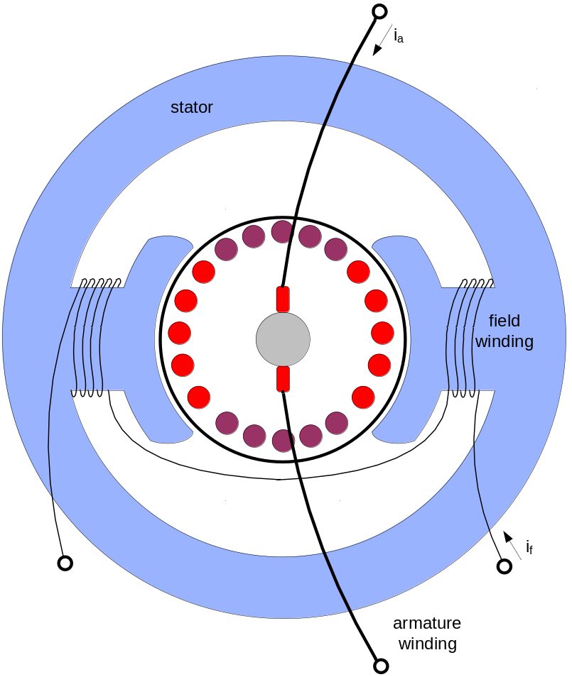
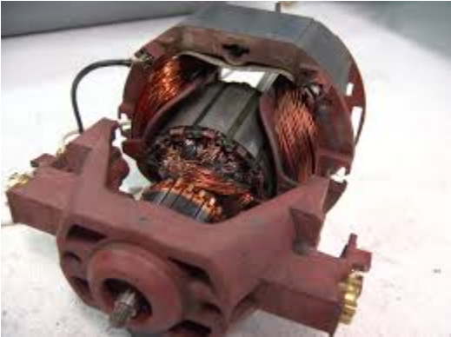
Basic Structure of a Wound Field DC Machine

DC Machine Equations:
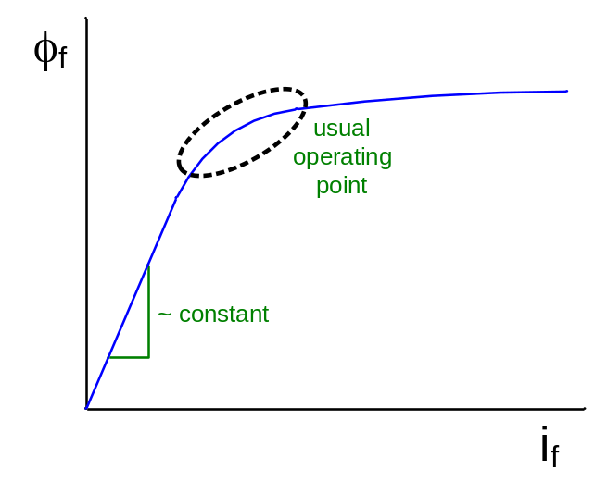
Faraday’s Law:

v_{f} = R_{f} i_{f} + L_{f}

v_{a} = R_{a} i_{a} + L_{a} + e_{a}

e_{a} = k i_{f} ω = K_{e} ω

T_{em} = k i_{f} i_{a} = K_{t} i_{a}
load torque
Newton’s 2nd Law:

ΣTmech = Tem J + b ω + T_{L} = T_{em}
viscous damping

Steady State Operation:

i_{f} = I_{f} , i_{a} = I_{a} , ω = constant

V_{f} = R_{f} I_{f}

V_{a} = R_{a} I_{a} + E_{a}

T_{em} = K_{t} I_{a}

Example:
National Electrical Manufacturer’s Association

100 Hp 1750 RPM NEMA 503 frame

R_{a} = 0.0144 Ω @25 ºC (0.0173 Ω @ operating temperature)

L_{a} = 1.1 mH

K_{t} = 0.885 K_{e} = 1.27

ω = 1750 RPM = 183

E_{a} = K_{e} ω = 1.27 x 183 = 233 volts

rated power: P_{r} = T_{r} ω_{r} → T_{r} = = = 407 N-m = 300 ft-lb_{f}

I_{ar} = = = 339 A

rated IR voltage drop: R_{a} I_{a} = 339 A x 0.0173 Ω = 5.9 volts
(@ rated operating temperature)

rated machine voltage:
V_{ar} = R_{a} I_{ar} + E_{a} = 238.9 volts (~ 240 Vdc)

no load speed:
ω_{nl} = 1750 RPM x = 1794 RPM

What is the stall current?

I_{a_stall} = = = 16,590 A!!! This is why we current regulate machines!

Wound Field DC Machine Equivalent Circuit

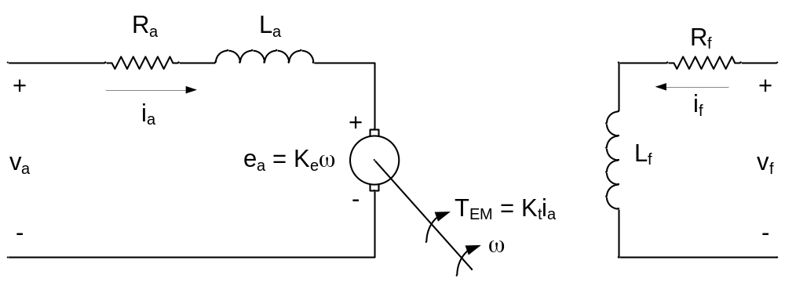

v_{a} = R_{a} i_{a} + L_{a} + e_{a} v_{f} = R_{f} i_{f} + L_{f}

e_{a} = K_{e} ω

T_{em} = K_{t} i_{a}

Speed-Torque Characteristics:

v_{a} = V φ_{f} = constant → K_{e} = K_{t} = constant

e_{a} = E_{a} I =

ω = = = - T_{em}

T_{em} = K_{t} I_{a} = K_{t}

Motor Constant Squared (K_{m}²)

K = = =

K_{m} = =

What does the speed-torque curve look like for the DC Machine?

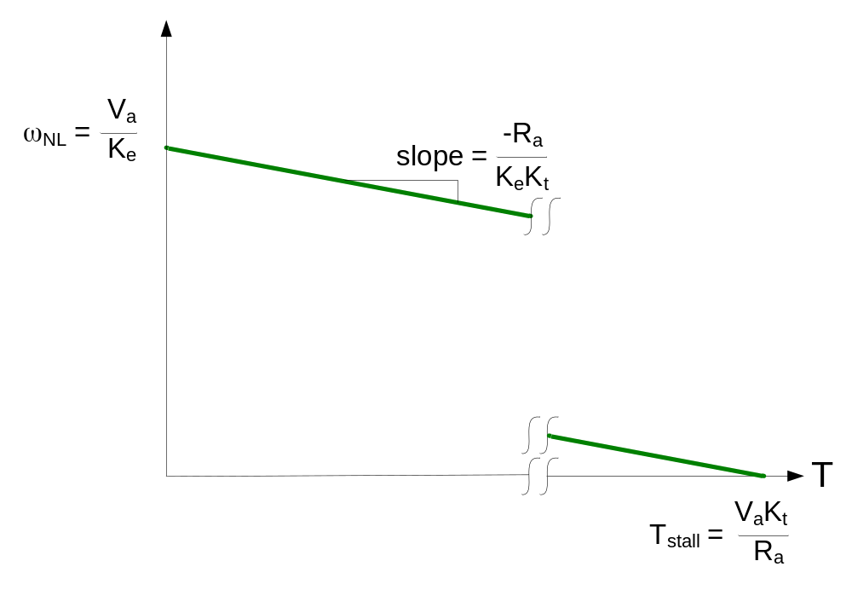
Speed Torque of a DC Machine with Constant Field Flux

Ways of varying speed:
- R – add external resistance (used in the “prehistoric days”) ← Trolley Car
- V – standard for reducing speed (operating below rated speed)
- φ_{f} – standard for increasing speed (operating above rated speed)

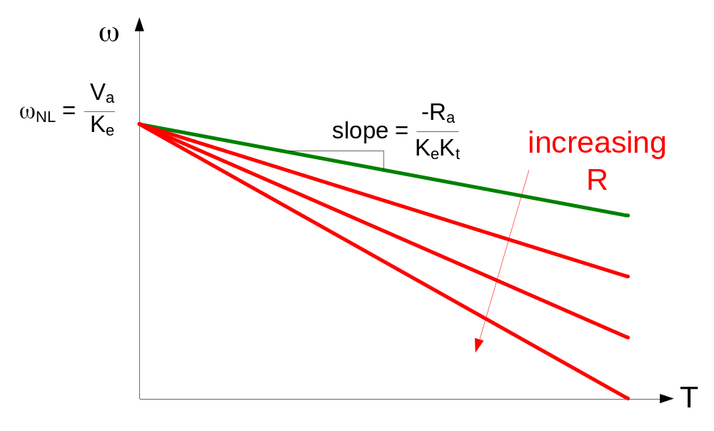
Speed Torque of a DC Machine

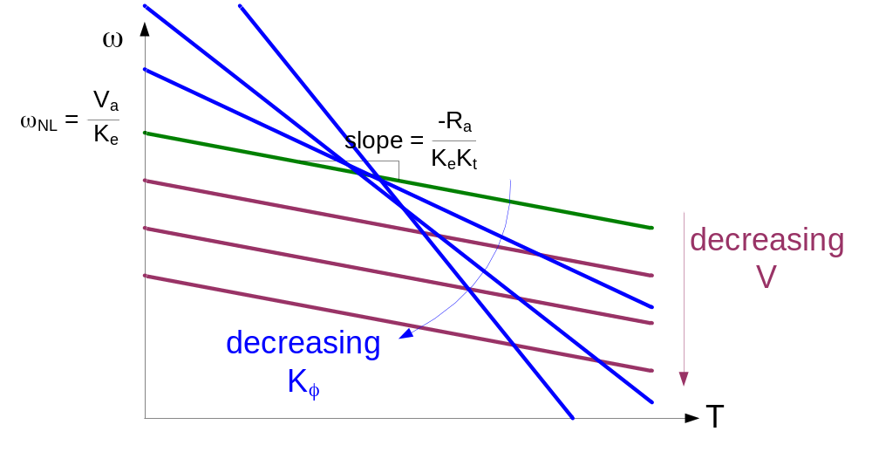
Speed Torque of a DC Machine

Note: catastrophic problem in lightly loaded or no load DC drives which loose field excitation

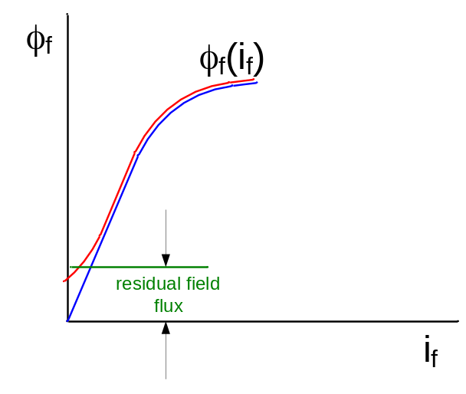
Field Flux vs. Field Current Showing Residual Field Flux

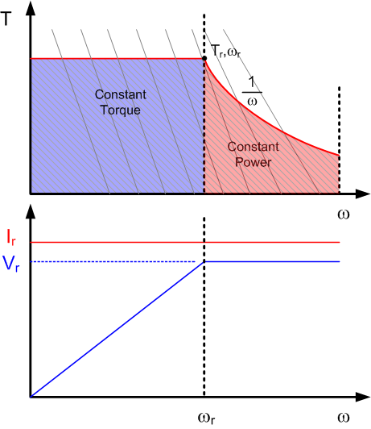
Capability curve for separately excited DC Machine

Limitations:
- Continuous – Thermal Limits
- Occasional – Thermal Limits
– Load Cycle (Repeat Application of High Loads, Frequency, Duration)
- Instantaneous – Commutation

Torque Production in Wound Field DC Machines

T_{em} = K_{t} i_{a} = K_{f} i_{f} i_{a}

Why should we use armature current for speed/torque control instead of field current?

Because the field circuit time constant is typically much larger than the armature circuit time constant.

Field Circuit τ_{e} >> Armature Circuit τ_{a}

This means that the time (or energy) required to change the field circuit is much larger than the time (or energy) to change the armature circuit.
Flux Distribution in DC Machines

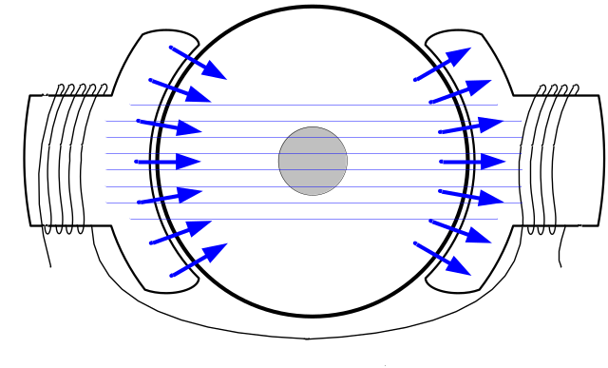
Flux with Field Excitation Only
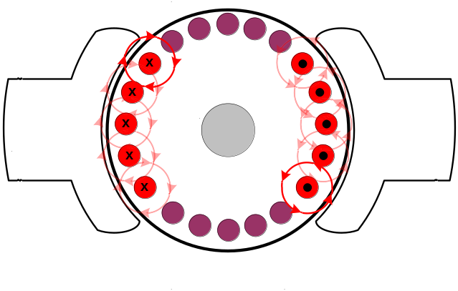
Flux with Armature Excitation Only
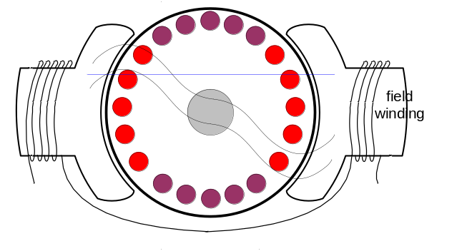
Flux with Field and Armature Excitation

Problem: Skewing of the field flux is known as Armature Reaction.

Armature Reaction Mitigation Techniques:

- Rotate the brushes (helps for unidirectional applications only)
- Add interpoles
- Add compensating winding

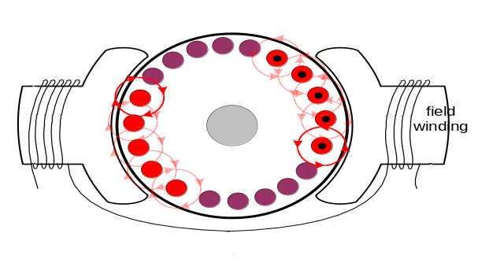
Rotation of Brushes
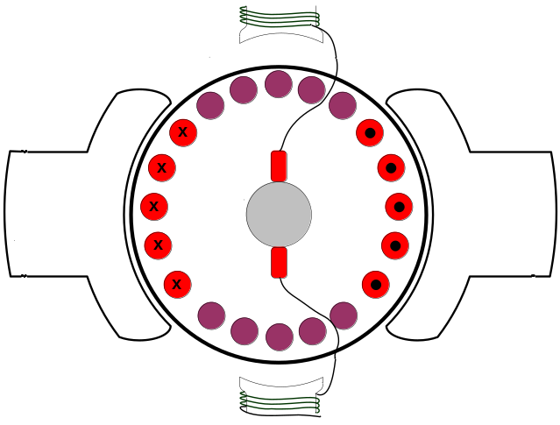
Interpoles
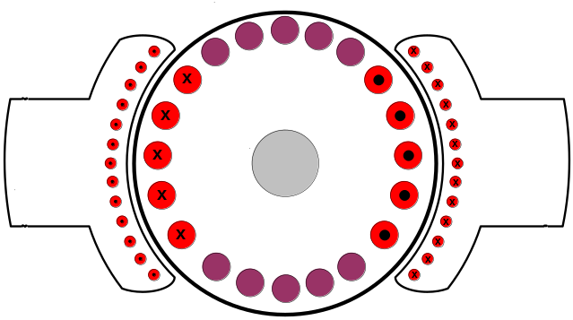
Armature Compensating Winding

Note: BLDC Motors also have armature reaction effects.

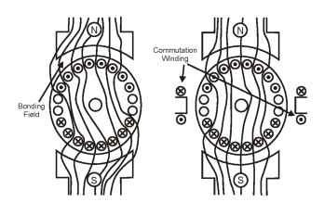
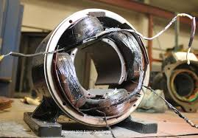
Interpoles Field Windings
DC Machine with Interpoles (Commutation Windings)

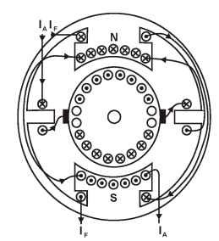
DC Machine with Interpoles and Compensating Windings

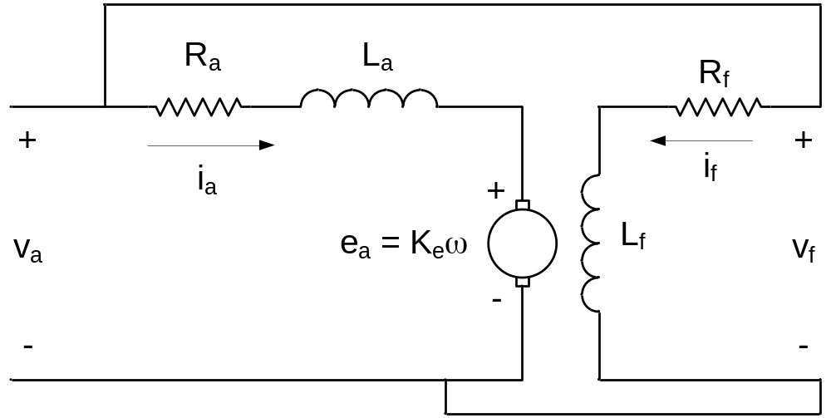
Shunt Wound DC Motor

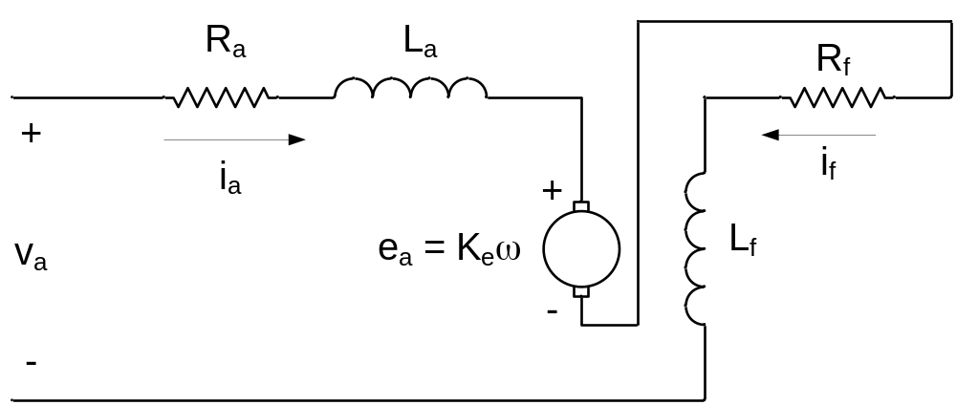
Series Wound DC Motor

What does speed-torque curve for series wound DC motor look like?

